AY2026-27

Executive Members
Sr.No. | Name | Post | Photo
1 | Jeel Gujrati | Secretary | 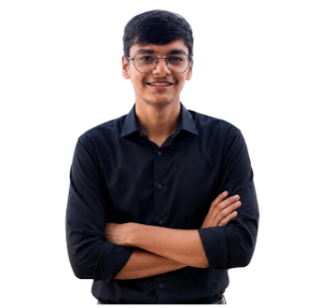
2 | Tirth Prajapati | Joint Secretary | 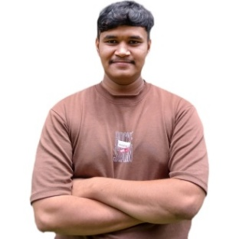
3 | Rishabh Prajapati | Joint Secretary | 
4 | Krish Akbari | Treasurer | 
5 | Prachi Bachani | Treasurer | 

Branch Coordinators
Sr.No. | Branch Name | Student Name | Photo
1 | Mechanical Engineering | Prince Prasad | 
2 | Production Engineering | Jay Patil | 
3 | Electronics & Communication Engineering | Rudra Prajapati | 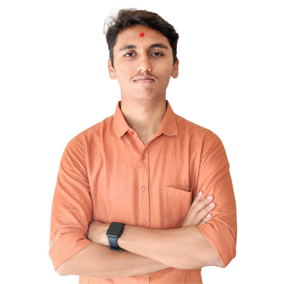
4 | Electronics Engineering | Krutarth Vandara | 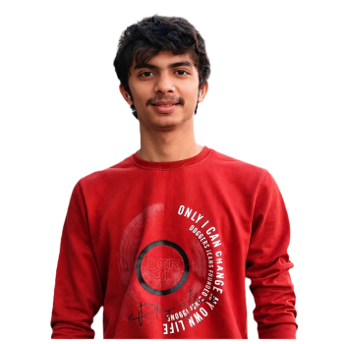
5 | Electrical Engineering | Hinal Unagar | 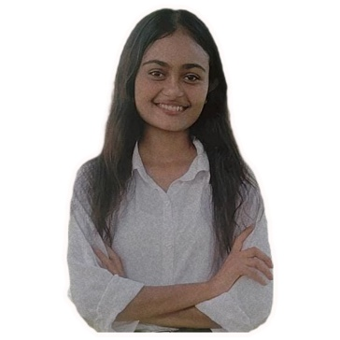
6 | Computer/Information and technology Engineering | Anushka Pawar | 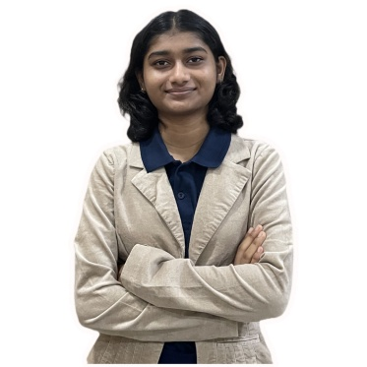

Inventory Lead
Sr. No. | Name | Photo
1 | Mohit Kapadiya | 
2 | Kushal Dobariya | 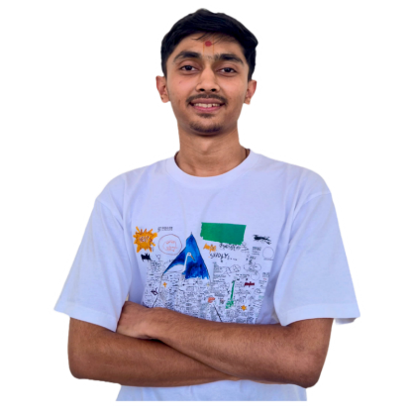

Social media Lead
Sr. No. | Name | Photo
1 | Jay Rathod | 

Documentation Leads
Sr.No. | Name | Photo
1 | Kush Prajapati | 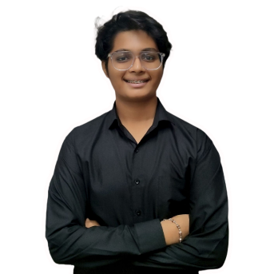
2 | Dev Patel | 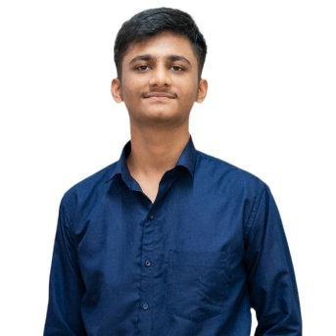
3 | Kavya Shah | 

Graphics Leads
Sr.No. | Name | Photo
1 | Malav Patel | 
2 | Manav Tajpara | 
3 | Kenil Patel | 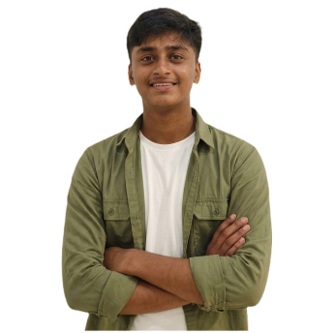

Photography Lead
Sr.No. | Name | Photo
1 | Nihar Bambharoliya | 
2 | Khush Goyani | 

Website Lead
Sr.No. | Name | Photo
1 | Anushka Pawar | 